**Doctor table:-**

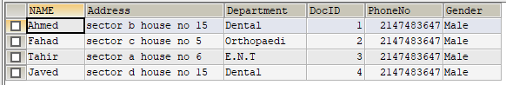

**Patient table:-**

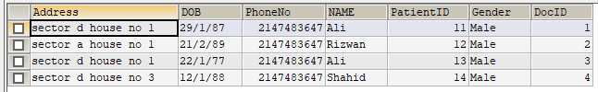

**Bill table:-**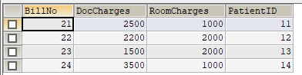

**Room table:-**

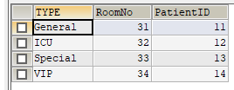

**Treats table:-**

